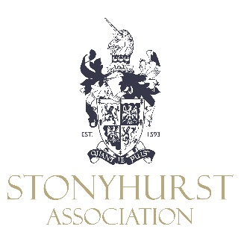

Poetry 1982 Reunion Programme
Saturday 24th September and Sunday 25th September 2022

The programme for the weekend is as follows:

Saturday 24th September

12.30pm Register in the Pieta Gallery
1.00pm Buffet Lunch

2.30pm Tour to take in new areas

7.30pm Drinks Reception in the Top Ref

8.00pm Reunion Dinner in the Top Ref (OS only)
Dress code: Black Tie
11.00pm Departure

Sunday 25th September

11.00am Mass in St Peter’s Church

12.00pm Coffee in the Do Room

12.15pm Tour of the Collections and the Old Chapel Museum
(To be confirmed)

The cost for the weekend is £150.00 per person for single occupancy in Theodore House (in the College grounds), for one night, and includes bed and breakfast accommodation, meals as on the programme, pre-dinner drinks and wine/soft drinks with lunch and dinner. Accommodation is also available on Friday evening at Theodore House, the cost for two nights will be £195.00. Some twin rooms are also available, prices are on the booking form. For those who wish to make their own accommodation arrangements the cost will be £99.00. Please click the link below to complete the booking form.

Poetry 1982 Booking Form

Our cancellation policy – owing to costs that are incurred please note that:
Bookings cancelled at least 30 days before the event will receive 100% refund. Bookings cancelled at least 14 days before the event will receive a 50% refund. Booking cancelled less than 14 days before the event will not be subject to a refund.

Mrs B Sillitoe, Stonyhurst Association, Stonyhurst College, Clitheroe, Lancashire, BB7 9PZ
Tel 01254 827043 e-mail association@stonyhurst.ac.uk

